Triangular distribution

Def

A distribution whose graphs is a triangle.

PDF

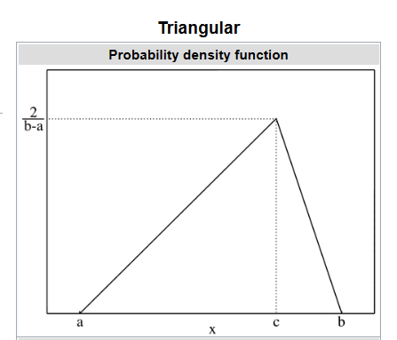

Figure 1.1

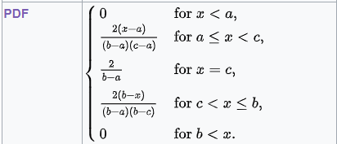

Proof:

By definition of PDF.

CDF

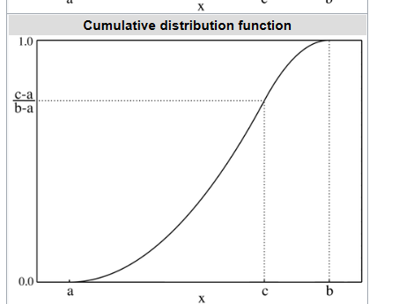

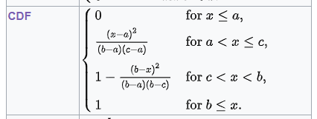

Proof:

See PDF graph from above figure (Figure 1.1)

Way 1:

Integrate PDF. The relationship between PDF and CDF.

Way 2:

Evaluate the area. The definition of CDF.

Expected Value



Proof

By the defintion of Expected Value.

The mean of X is

$$E\left[X\right]$$

= $$integral\left(x\operatorname{Pr}\left(x\right)dx,x=−inf,x=\inf{}\right)$$

= ￼

+ $$integral\left(\frac{2\left(x−a\right)}{\left(b−a\right)\left(c−a\right)}x dx,x=a,x=c\right)$$

+ $$integral\left(\frac{2}{b−a}x dx,x=c,x=c\right)$$

+ $$integral\left(\frac{2 \left(b−x\right)}{\left(b−a\right)\left(b−c\right)}x dx,x=c,x=b\right)$$

+ $$integral\left(0 x dx,x=b,x=\inf{}\right)$$

= $$0$$

+ $$\left(\frac{2}{\left(b−a\right)\left(c−a\right)}\right)\left[integral\left(x^{2}dx,x=a,x=c\right)−integral\left(axdx,x=a,x=c\right)\right]$$

+ $$0$$

+ $$\left(\frac{2}{\left(b−a\right)\left(b−c\right)}\right)\left[integral\left(bx dx,x=c,x=b\right)−integral\left(x^{2 }dx,x=c,x=b\right)\right]$$

+ $$0$$

= $$0$$

+ $$\left(\frac{2}{\left(b−a\right)\left(c−a\right)}\right)\left[diff\left(\frac{1}{3}x^{3} dx,x=a,x=c\right)−diff\left(\frac{a}{2}x^{2 }dx,x=a,x=c\right)\right]$$

+ $$0$$

+ $$\left(\frac{2}{\left(b−a\right)\left(b−c\right)}\right)\left[diff\left(\frac{b}{2}x^{2} dx,x=c,x=b\right)−diff\left(\frac{1}{3}x^{3 }dx,x=c,x=b\right)\right]$$

+ $$0$$

= $$0$$

+ $$\left(\frac{2}{\left(b−a\right)\left(c−a\right)}\right)\left[\left[\frac{1}{3}a^{3}−\frac{1}{3}c^{3}\right] −\left[\frac{a}{2}a^{2 }−\frac{a}{2}c^{2}\right]\right]$$

+ $$0$$

+ $$\left(\frac{2}{\left(b−a\right)\left(b−c\right)}\right)\left[\left[\frac{b}{2}c^{2}−\frac{b}{2}b^{2}\right]−\left[\frac{1}{3}c^{3}−\frac{1}{3}b^{3}\right]\right]$$

+ $$0$$

= $$0$$

+ $$\left(\frac{2}{\left(b−a\right)\left(c−a\right)}\right)\left[\frac{1}{3}a^{3}−\frac{1}{3}c^{3}−\frac{a}{2}a^{2}+\frac{a}{2}c^{2}\right]$$

+ $$0$$

+ $$\left(\frac{2}{\left(b−a\right)\left(b−c\right)}\right)\left[\frac{b}{2}c^{2}−\frac{b}{2}b^{2}−\frac{1}{3}c^{3}+\frac{1}{3}b^{3}\right]$$

+ $$0$$

= $$0$$

+ $$\left[\frac{2a^{3}}{3\left(b−a\right)\left(c−a\right)}a^{3}−\frac{2c^{3}}{3\left(b−a\right)\left(c−a\right)}−\frac{a^{3}}{\left(b−a\right)\left(c−a\right)}+\frac{ac^{2}}{\left(b−a\right)\left(c−a\right)}\right]$$

+ $$0$$

+ $$\left[\frac{bc^{2}}{\left(b−a\right)\left(b−c\right)}−\frac{b^{3}}{\left(b−a\right)\left(b−c\right)}−\frac{2c^{3}}{3\left(b−a\right)\left(b−c\right)}+\frac{2b^{3}}{3\left(b−a\right)\left(b−c\right)}\right]$$

+ $$0$$

= $$\left(\frac{1}{3}\right)\left(a+b+c\right)$$

Variance

正在插入影像...

Proof:

Skip

Median

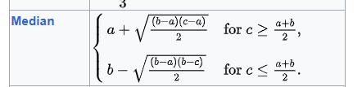

Proof:

Skip

Mode

正在插入影像...

Proof:

Skewness

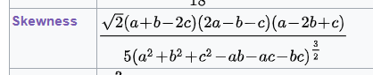

Proof:

Skip

Ref

[Triangular distribution - Wikipedia](https://en.wikipedia.org/wiki/Triangular_distribution)